

Sinhgad Technical Education Society’s

# SINHGAD ACADEMY OF ENGINEERING

Department of Computer Engineering

### **Name :- Sham Anil Mane**

### **Class :- TE (B)**

**Roll No. :- COTB13**

# Assignment II

### Title: Execute and Monitor Project Plan **Food Order Management System**

Execute and Monitor Project Plan :

* Update % Complete with current task status.
* Review the status of each task.
* Compare Planned vs. Actual Status.
* Review the status of Critical Path.
* Review resources assignment status.

Requirements: Project Management tool-

1. Edrawmax Project Management Software

Theory:

Execution and monitoring is an important phase in project management. Scheduling,

assigning timeline are some measures to achieve better results.Edraw Max provides timeline generation.

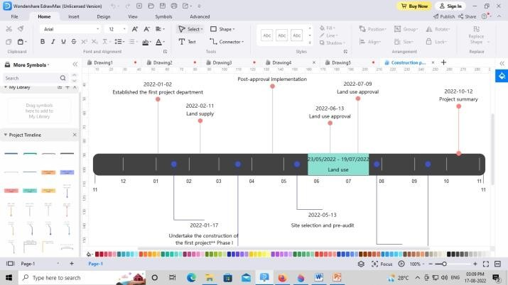

Edraw Max provides Pie, Bar and Line generation. Here is the sample representation:

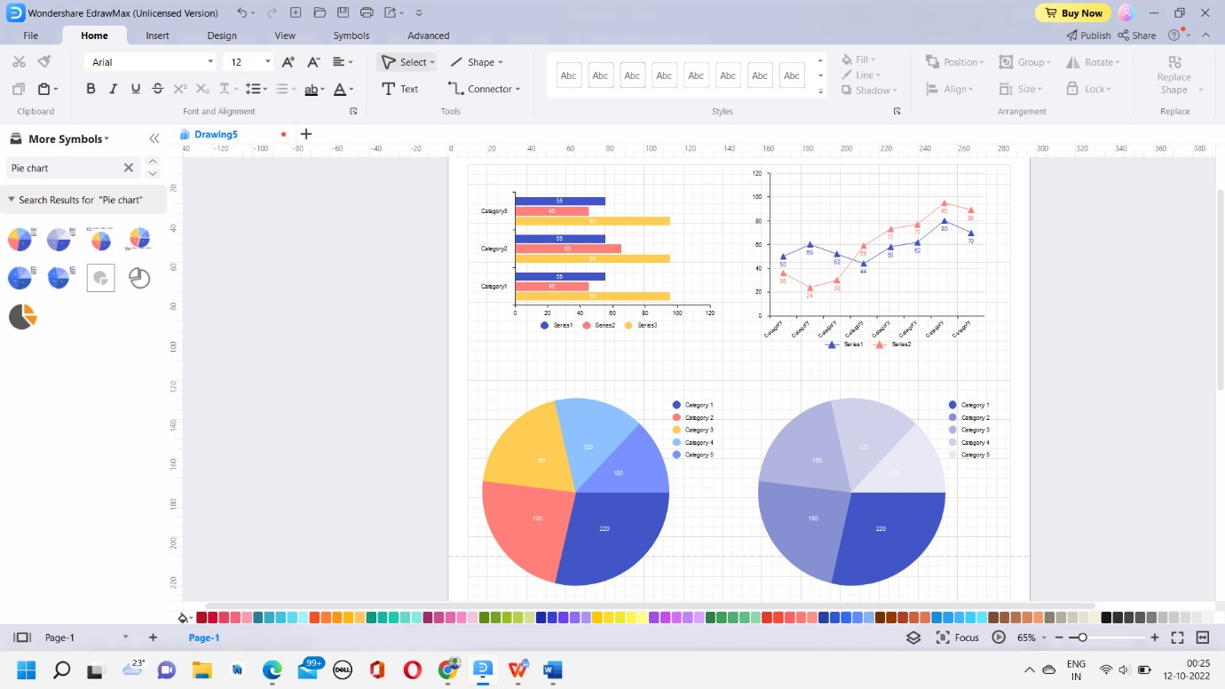

In the project Food Order Management System, the project manager first have to create a project plan for implementation of the project. The whole project is divided into different tasks; the tasks are then subdivided into the subtasks until the project approaches to the simpler steps.

Food Order Management System is divided into different tasks as follows:

1. Initiation
2. Planning
3. Execution
4. Monitoring and Control
5. Closing

This task is further divided into following subtasks: Initiation:

* Information Collection
* Define Scope and Objectives
* Identify User requirements

Planning:

* Draw ER Diagram
* Planning of Database
* Plan resources
* Create Design Execution:
* Create Database
* Design Front end
* Manage Resources
* Run Application Monitoring and Control:
* Monitor Project
* Testing
* Fix Bugs Closing:
* Create Project Report
* Check User Requirement

**Resources:**

Following are the resources used in the implementation of Food Order Management System:

* Budget :-

The Budget of this project is RS.8000

* Schedule :-

Project start date:- 2 Sept 2022

End date:- 30 Oct 2022

* Manpower:-

18 employees are required for this project.

* Software:-

Microsoft visio:- ER Diagram Mysql :- Database creation

Some other software required for project.

* Hardware:-

There different hardware required for the project development.

## Critical Path:

Critical path method(CPM) is resource-utilization algorithm for scheduling a set of project activities. In this project 8 tasks are very important.

Task are as following:

1. Discuss the Project:

Project discussion is very important. Project is discussion provides help for studying project requirements.

1. Information Collection:

Gathering information related to the project that is very important for finding resources.

1. Draw ER diagram:

ER diagram is important for database creation. Without this database is hard to

design.

1. Create Database:

Database is created for the Food Order Management System.

1. Run Application:

For improving project quality run application.

1. Testing:

Project testing is important for removing bugs in the project.

1. Monitor Project:

To improve the project quality monitoring project.

1. Create Project report.

## Conclusion:

Thus, we have successfully learnt and understood the concept of various SPM tools such as Gantt chart, Pie chart, Bar chart and Line chart. And also identified the resources required to complete the Food Order Management System Project.